JCS 100.1 and 100.4

GP1

**In-text citation**

**List of references**

References

Kuchar, M. (2000). *Kuchars, kitchens, and kuchen*. New York, NY: Skyscraper Publishing.

Stefan and Anna Kuchar arrived at Ellis Island in the winter of 1898 (Kuchar, 2000).

GP2

**In-text citation**

**List of references**

A 2014 Ford Focus in good condition is worth between $6,200 and $7,300 (Upton, 2017).

References

Upton, A. (2017). *Car value almanac*. Detroit, MI: Automotive Press.

GP3

**In-text citation**

**List of references**

References

Martinez, P. (2016). The hiker's guide to Yosemite. Chicago, IL: Travel Books.

One of the most popular features of Yosemite National Park is El Capitan, a vertical rock formation that is about 3,000 feet high (Martinez, 2016).

JCS100.3

GP1

“Direct quotation from Kellen West” (p. 32).

Here are a few sentences with your own ideas.

Here are a few sentences with your own ideas.

These are the words of Kellen West that support your points.

As Kellen West (2011) explains. . .

As Kellen West (2011) explains. . .

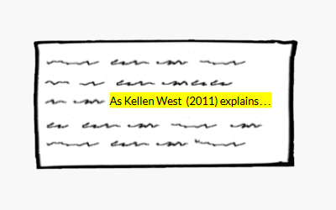

Ideas from your source that support your points

Your ideas

GP2

“Direct quotation from Tara Browning” (p. 40).

Here are a few sentences with your own ideas.

Here are a few sentences with your own ideas.

These are the words of Tara Browning that support your points.

As Tara Browning (2016) explains. . .

As Tara Browning (2016) explains. . .

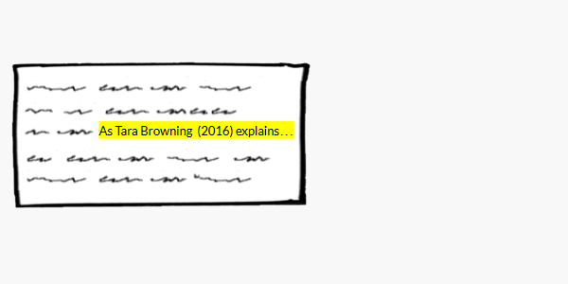

Your ideas

Ideas from your source that support your points

GP3

Here are a few sentences with your own ideas.

Here are a few sentences with your own ideas.

These are the words of Paula Martinez that support your points.

“Direct quotation from Paula Martinez” (p. 4).

As Paula Martinez (2015) explains. . .

As Paula Martinez (2015) explains. . .

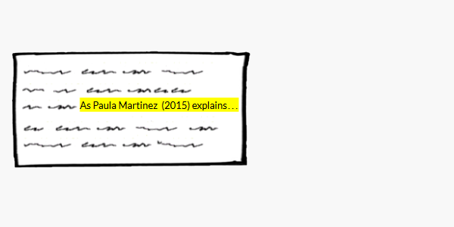

Ideas from your source that support your points

Your ideas

Direct quotation from Tara Browning with   
page number at the end

Ideas of Tara Browning that   
support your points

